Program 8: Migrating a Maven Project to Gradle using gradle init --type pom
Procedure
Step 1: Create a Maven Based Application
cd ~/devops
mvn archetype:generate -DgroupId=com.example -DartifactId=MyMavenToGradle
-DarchetypeArtifactId=maven-archetype-quickstart DinteractiveMode=false

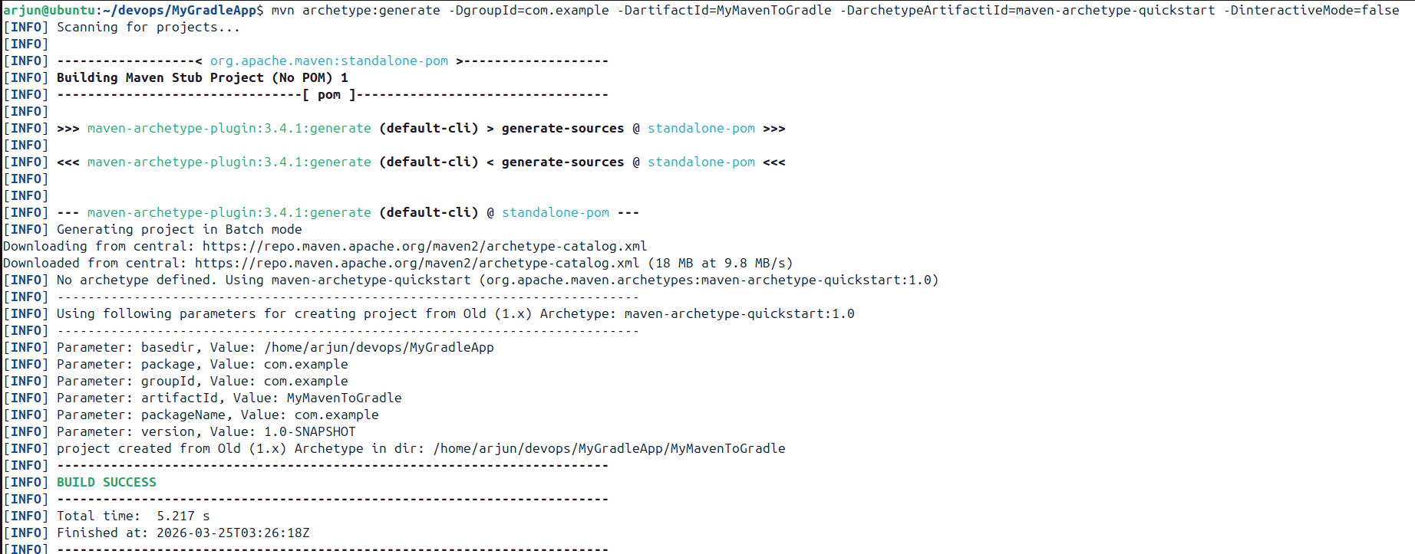

Step 2: Navigate to the Project Directory and View Structure
cd MyMavenToGradle
tree
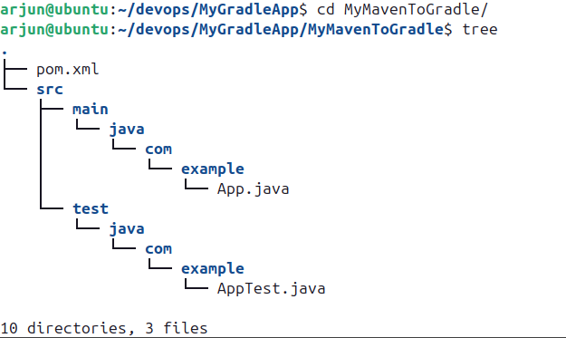

Step 3: Open and Edit pom.xml
gedit pom.xml
pom.xml
<project xmlns="http://maven.apache.org/POM/4.0.0"
xmlns:xsi="http://www.w3.org/2001/XMLSchema-instance"
xsi:schemaLocation="http://maven.apache.org/POM/4.0.0
http://maven.apache.org/maven-v4_0_0.xsd">
<modelVersion>4.0.0</modelVersion>
<groupId>com.example1</groupId>
<artifactId>MyMavenToGradle</artifactId>
<packaging>jar</packaging>
<version>1.0-SNAPSHOT</version>
<name>MyMavenToGradle</name>
<url>http://maven.apache.org</url>
<!-- Properties: Customize Java version or plugin versions -->
<properties>
<maven.compiler.source>11</maven.compiler.source>
<maven.compiler.target>11</maven.compiler.target>
</properties>
<dependencies>
<dependency>
<groupId>junit</groupId>
<artifactId>junit</artifactId>
<version>3.8.1</version>
<scope>test</scope>
</dependency>
</dependencies>
<!-- Build: Configuring plugins and build settings -->
<build>
<plugins>
<!-- Example: Maven Compiler Plugin to compile Java code -->
<plugin>
<groupId>org.apache.maven.plugins</groupId>
<artifactId>maven-compiler-plugin</artifactId>
<version>3.8.1</version>
<configuration>
<source>1.6</source>
<target>1.6</target>
</configuration>
</plugin>
<!-- Example: Maven Surefire Plugin to run tests -->
<plugin>
<groupId>org.apache.maven.plugins</groupId>
<artifactId>maven-surefire-plugin</artifactId>
<version>2.22.2</version>
</plugin>
<plugin>
<groupId>org.apache.maven.plugins</groupId>
<artifactId>maven-jar-plugin</artifactId>
<version>3.1.0</version>
<configuration>
<archive>
<manifestEntries>
<Main-Class>com.example1.App</Main-Class>
</manifestEntries>
</archive>
</configuration>
</plugin>
</plugins>
</build>
</project>
The pom.xml configures the Maven project with JUnit as a test dependency, and includes the maven-compiler-plugin (Java 1.6), maven-surefire-plugin, and maven-jar-plugin with the Main-Class manifest entry set to com.example1.App.

Step 4: Build and Install the Maven Project
mvn clean install

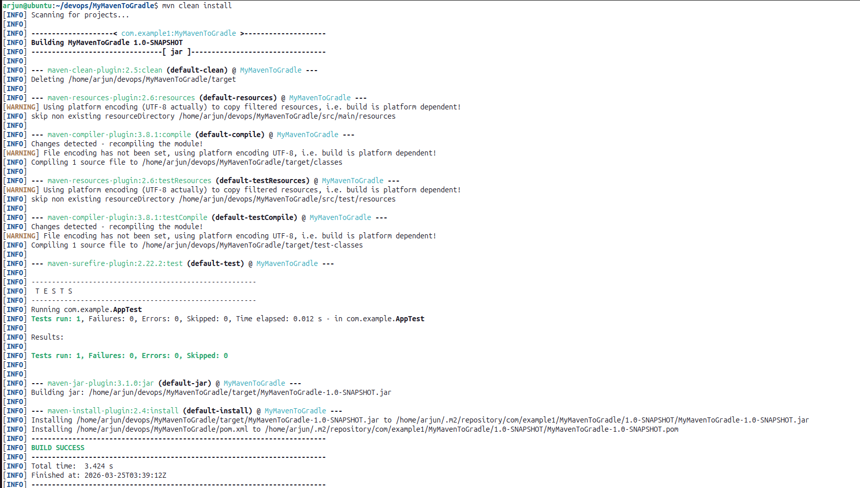

Step 5: Migrate from Maven to Gradle using gradle init --type pom
gradle init --type pom

